

|  |
| --- |
| Type Racer  2019/2020 |
|  |
| January 5  LCOM Project  Authored by: Diana Freitas & André Gomes |



Table of Contents

Table of Figures 8

Goals 9

Specific course goals 9

User instructions 10

Starting Screen 10

Countdown 10

Classic Mode 11

Correct State 12

Typing Error State 12

Error Message State 13

Results 13

Save Score 14

Timed Race 14

High Scores 15

Project Status 16

Timer 16

Functionality 16

Code 16

Keyboard 17

Functionality 17

Code 17

Graphics Card 17

Functionality 17

Code 18

Mouse 18

Functionality 18

Code 18

RTC 18

Functionality 18

Code 19

Code organization/Structure 19

Game.c / game.h 19

Highscores.c / highscores.h 20

Rtc.c / rtc.h / rtc_macros.h 20

Sentences.c / sentences.h 20

Vc.c / vc.h 20

Xpm.h 21

Functions call graph 21

Implementation details 22

Interruptions loop, event driven code and state machine 22

Timer & Graphics Mode 22

Memory Allocation and Deallocation 23

DrawSentence()/DrawInput() 24

Keyboard 24

Highscores 25

Conclusions 26

Installation instructions 27

Figures 27

# Table of Figures

Figure 1 - Main Menu 6

Figure 2 - Classic Mode Screen 7

Figure 3 - Normal Game State 8

Figure 4 - Typing Error Game State 8

Figure 5 - Error Message Game State 9

Figure 6 - Results Screen 9

Figure 7 - Timed Race Game Mode 10

Figure 8 - Results Screen 11

Figure 9 - High Scores Screen 11

Figure 10 - Staring Function Call Graph 17

Figure 11 - Main Data Structures 1 23

Figure 12 - Main Data Structures 2 24

Figure 13 - Main Data Structures 3 (Game) 25

Figure 14 - Main Data Structures 4 (Game) 26

Figure 15 - RTC Data Structure and some macros 27

Figure 16 - Sentences module data structures 28

# Goals

## Specific course goals

All the goals of the course were met, namely:

* Use of the hardware interface of the most common PC peripherals;
  + Timer, Mouse, Keyboard, Video Card and Real Time Clock
* Development of low level and embedded software
  + Use of low lever functions and registry access
* Programming, in a structured way, in C language
  + Use of the main while loop, data structures, documentation
* Use of various software development tools
  + Oracle VM VirtualBox
  + Minix 3
  + CLANG compiler and assembler
  + SVN: Version Control System
  + Redmine: Web application for project management
  + Doxygen
  + Visual Studio Code
  + GIMP

According to our Project Specification we also met the goals we intended for ourselves, implementing the devices we set out to implement.

# User instructions

## Starting Screen

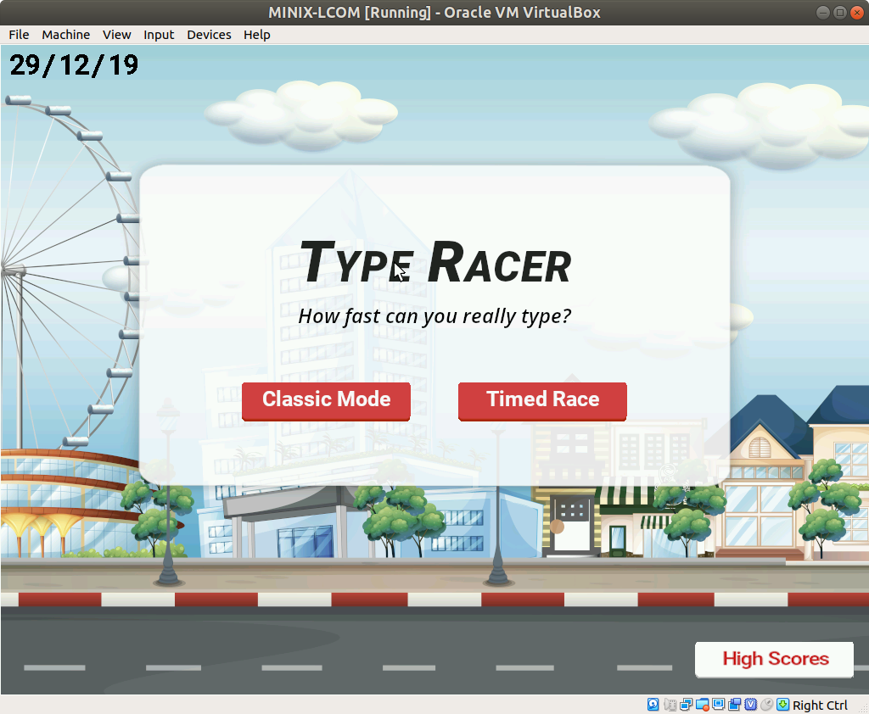

Figure 1 - Main Menu

At the start of the program, the user is presented with a main menu screen with the title of the game, the current date, a sub-sentence and 3 buttons equivalent to 3 options: “Classic Mode”, “Timed Race” and “High Scores”. It is possible to exit this main menu, thus exiting the game, by pressing *Esc*. at this point the user can choose one of the available game modes or the “High Scores” option.

## Countdown

After pressing one of the game mode buttons, a countdown will be presented to indicate the start of the game and to allow the user to get ready.

## Classic Mode

Figure 2 - Classic Mode Screen

In Classic Mode a random sentence is shown on the screen for the user to write, a blank space where the written sentence will appear and a yellow car that moves accordingly to the progress made. At this point the user can press *Esc* to exit the current game mode and return to the main menu or start playing. To do this, the user needs to type the sentence he sees on the screen as fast as he can while trying not to commit spelling mistakes. The progress will be shown accordingly.

### Correct State

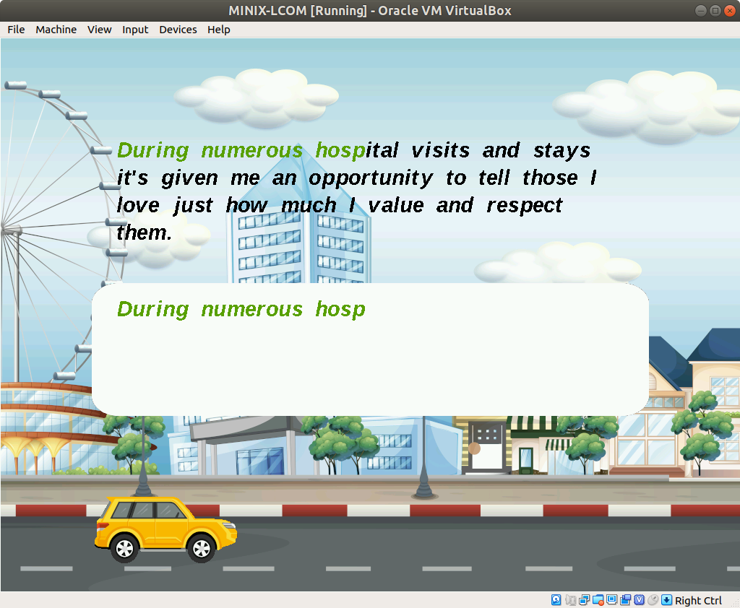

Figure 3 - Normal Game State

If the input is correct (the same as in the sentence) it will be written in the white box, the corresponding letter will turn green and the car will advance to the right.

### Typing Error State

Figure 4 - Typing Error Game State

If the input is incorrect, the letters on the white box will become red and the corresponding letters on the sentence will also turn red. To return to the normal state the user needs to press *backspace* until all letters on the white box become green.

### Error Message State

Figure 5 - Error Message Game State

When the game detects 5 errors it will enter an *Error Message State* in which a prompt will appear to warn the user to press *Backspace*,if the user presses any other key (i.e. a letter), the game will not accept it and won’t display it on the screen. Once the *Backspace* key is pressed once, the game returns to *Typing Error State*.

### Results

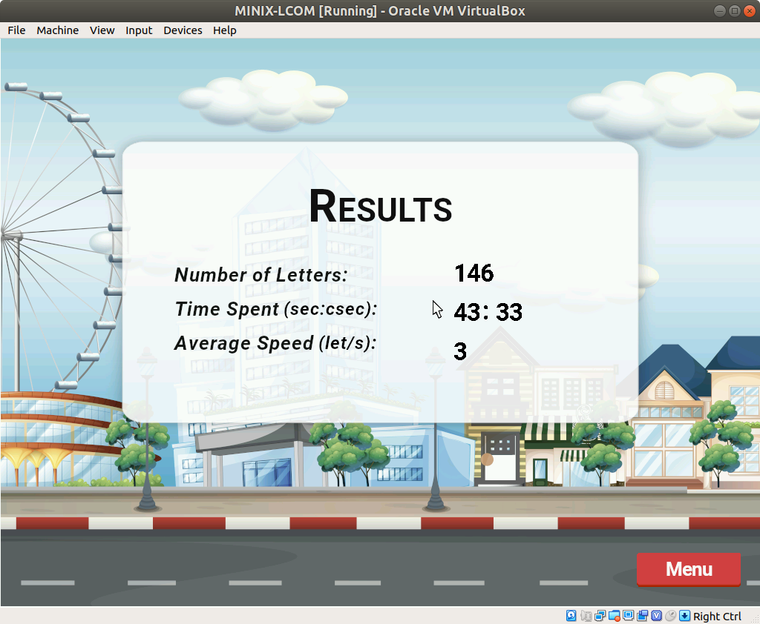

Figure 6 - Results Screen

When the user ends writing the sentence, the Results screen shows the number of letters typed, the time it took and the average speed in letters per second. The user can exit this screen by pressing the *Menu* button or pressing the *Esc* key.

### Save Score

After exiting the Results screen, the user should input a username to save his score. The result can be viewed along with the date and hour when it was achieved and also with its correspondent username at the High Scores, but only if it reached the top 5.

## Timed Race

The Timed Race mode follows some of the formatting for the *Classic Mode*: there is a countdown and the same correct/error states. However, in this mode there is also a 1 minute timer counting upwards. The user must write as many words as he can in that time, during which multiple random sentences are generated.

Figure 7 - Timed Race Game Mode

At the end of the 1 minute mark the Results screen shows up. The user is presented with the amount of characters he was able to correctly type in that time and his average speed.

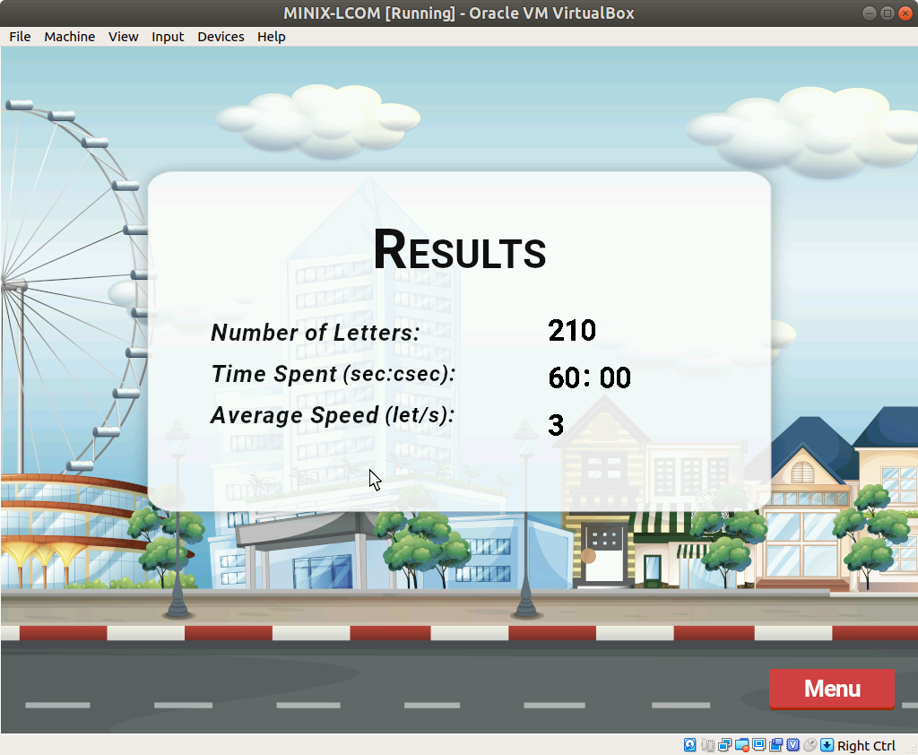

Figure 8 - Results Screen

## High Scores

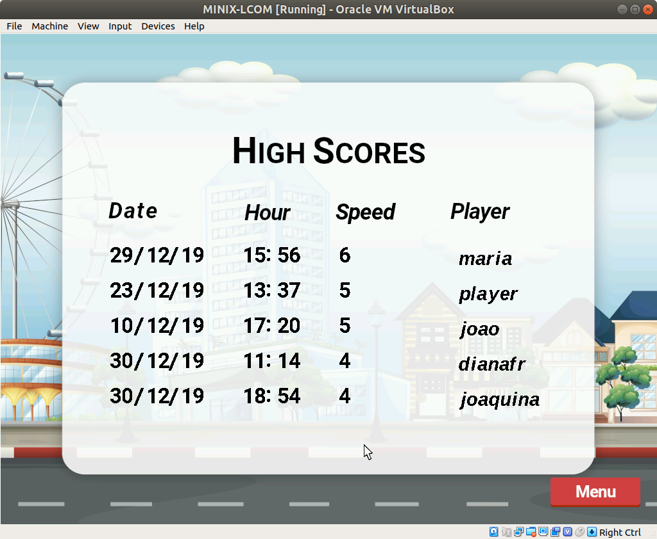

Figure 9 - High Scores Screen

It is possible to see the saved high scores (including the scores saved from previous sessions on a text file) by pressing the corresponding option on the main menu. The user can exit this screen by pressing the button on the bottom right corner or by pressing the *Esc* key.

# Project Status

Functionalities implemented:

Timer, Keyboard, Mouse, Video Card, Real Time Clock.

Didn’t implement UART.

|  |  |  |
| --- | --- | --- |
| Device | What for | Interrupts |
| Timer | Update Game Status / Refresh Screen (Draw frames) | Yes |
| Keyboard | Main part of game – type sentences and usernames | Yes |
| Mouse | Button selection – to go to a game mode or to High Scores from the main menu and to go back to the menu or save a score | Yes |
| Video Card | Display on screen the state of the game | Yes |
| RTC | Save date and hour of a high score after a game is played and display current date on the screen | No |

## Timer

### Functionality

We used mostly the TIMER_COUNTER variable aided by the timer interrupt handler (void timer_int_handler()) to control the frame rate. Whenever there is a timer interrupt, depending on the current state, the timer is used differently to show the correspondent frame. The timer is used for the initial countdown and also to keep track of the time the user took in “Classic Mode” and to assure that in “Timed Race” the user as 60 seconds available. Most importantly, the timer is used to refresh the screen at 60 frames per second.

The function called on each timer interrupt depends on the current game state mode, but all of them draw the frame on the screen.

### Code

The game is based on time but mostly revolts around the usage of the TIMER_COUNTER variable throughout the program. With this, the directly timer related functions used were: *timer_subscribe_int(), timer_unsubscribe_int()* and *timer_int_handler().*

## Keyboard

### Functionality

In the main menu/results screen/high scores screen the keyboard expects the *Esc* make code to exit. In “Classic Mode” and “Timed Race” the keyboard is also used to exit the current mode by pressing *Esc* and to process the game state in *classic_mode()* or *timed_mode()*, using other functions such as *checkScanCode()* and *validateLetter().*

### Code

The *kbc_ih()* is used on every keyboard interrupt to process the scan code (uint8_t SCANCODE[2]) of the pressed key. If the program is in one of the 2 game modes, the functions *kbc_handle(), checkScanCode()* and *validateLetter()* will use the input and process it to refresh the game state. Also, in Save Score, the playerName (uint8_t scancode) function is called to process the keys pressed by the user when typing its username.

## Graphics Card

### Functionality

To refresh the screen we used page flipping [*page_flipping()*] and the only moving object we implemented was the moving car during the game screens, there was no need for collision detection. The VBE mode we used was 0x117 with a resolution of 1024x768 and 64K colors (5:6:5). For each state we implemented a different draw function [*drawMainMenu(), classicModeDraw(), timedModeDraw(), resultScreen(), highScoreScreen(), save_score_screen()*]. The main background,the high lights and the warning sign were obtained from *FreePik, FlatIcon* and *Vector Stock* (1,2,3). The letters and numbers use mainly *Roboto* font. All the images needed to be edited to change the proportions, sizes and to be converted to a new format (.xpm) using GIMP. These images can be found on the folder (proj/sprites) and subsequently subfolders.

1. <https://br.freepik.com/vetores-gratis/cena-da-cidade-com-a-roda-gigante-e-edificios_5348314.htm#page=2&query=Street&position=36>
2. https://www.flaticon.com/free-icon/warning_752755?term=warning%20sign&page=1&position=5
3. <https://www.vectorstock.com/royalty-free-vector/set-of-traffic-lights-icon-red-green-and-orange-vector-22987753>

### Code

We created some functions in the module that are reutilized often: *draw_xpm_image(), draw_sentence(), draw_input_sentence(), draw_letter(), get_double_buffer(), page_flipping()*, draw_pixel(), draw_name() and other functions used to draw the frames for each game mode (i.e. drawMainMenu()).

## Mouse

### Functionality

The mouse is used as a cursor in the main menu, results screen, save score screen and high scores screen. When the first frame of a mode/game state is drawn, the mouse cursor is shown at the center of the screen. We then detect its displacement on every interrupt and increment the initial position and the state of the left mouse button to keep track of the mouse’s movement and position on the screen and also to detect if the user is trying to press a button on screen.

### Code

The *mouse_ih()* is used on every mouse interrupt and, if the game is in one of the states mentioned above, the *mouse_handler()* function is called to assure the cursor is being correctly drawn and to refresh its current position. The mouse position is drawn on menu drawing functions, such as *drawMainMenu(),*  but only after all the other elements are drawn. In these functions, if statements are used to check if the cursor is on top of a button with the left mouse button pressed.

## RTC

### Functionality

The RTC is implemented to display the current date on the Main Menu screen and to describe the date and time when a new high score was beaten.

### Code

Because there was no lab assignment to the RTC we implement the needed functions for our program. *rtc_read()* to read the data and address registers and *rtc_read_date()* that is used at the start of the program to display the current date and to save the date and time to add a new high score. As well as some “supporting” functions such as *bcd()* and *bcd_to_binary() which allow us to check if the date and time information is stored in BCD and, if it is, to convert it to binary*.

# Code organization/Structure

These are some of the most important modules that were necessary to run the program. The device modules (except for the RTC and Video Card) are not included below because the functions used were developed in the labs.

## Game.c / game.h

Undoubtedly the most important module in our project. Here we have declared a lot of data structures (fig. 10 - 13), with descriptions as doxygen format comments, and the starting function of our program as well - *gameStart()*, in which the space needed for the game variables and data structures is allocated and where some of those variables are initialized. Only one “while loop” was used in this program, located in this module in the function *gameStateHandler()*. In this module there are also the functions that load the xpm’s in the beginning of the program and free the memory at the end, the functions to fill the screen, to calculate the game state and to validate inputs. It has an approximate 65% weight.

## Highscores.c / highscores.h

In this module we only have 4 functions: *get_highscores()* to retrieve the saved high scores from a .txt file and load them into memory; *new_highscore()* to check if the speed at the end of a round is enough to be a high score; *set_highscores()* to write the current high scores back to the .txt file and *add_new_highscore()* to insert the new high score and relocate the old ones. This corresponds to a weight of 5%.

## Rtc.c / rtc.h / rtc_macros.h

In the rtc_macros file we created the necessary macros to implement the RTC as well as a data structure to save the data we read from the device (fig. 14). On this module we also defined the functions needed to interact with the device. To be able to read the current date we need functions to aid *rtc_read_date()*, those are *isUpdating()*, *rtc_read()*, *bcd()* and *bcd_to_binary()*. Used in some places and easy to implement, corresponds to a 5% weight.

## Sentences.c / sentences.h

In the header file for this module we implemented more data structures to save information about each letter and number, as well as to save the sentences used in the game (fig. 15). Arrays were created to store all the letters, numbers and the error message as well as a two dimensional array to store the sentences. There are also the respective functions to load this data into memory : *loadLetters(), loadsentences(), allocateTwoDimenArrayOnHeapUsingMalloc()* and to free the memory allocated at the end of the program: destroyTwoDimenArrayOnHeapUsingFree(…) and destroySentencesAndLetters().

## Vc.c / vc.h

This module is included because we not only used some of the functions needed for the lab assignment, such as : *vbe_get_info_mode()*, *graphics_mode()* and *draw_xpm_image()*; but also added a lot specific to our program: *draw_sentence(), draw_letter(), draw_name()*. As well as the functions needed to execute page flipping : *get_double_buffer(), page_flipping()* and *free_double_buffer().* It constributes with a weight of 15%.

## Xpm.h

In this file we have the #include of all the xpm files used, 95 in total.

## Functions call graph

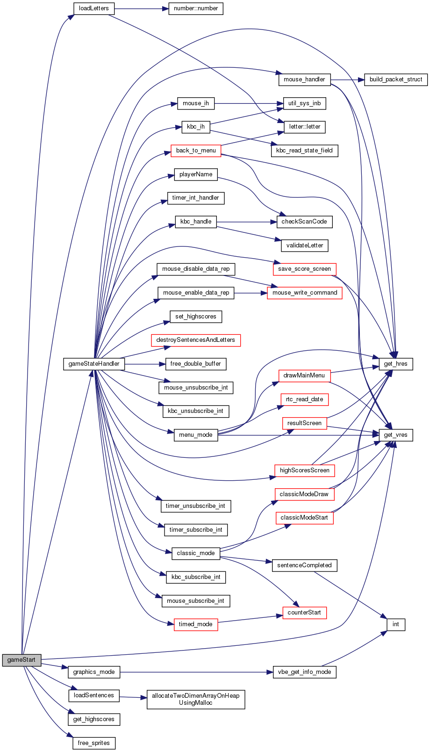

Figure 10 - Staring Function Call Graph

# Implementation details

The implementation of most of the project’s features required knowledges acquired in Theoretical Lessons and specially in Labs but also some other details that we had to explore and learn throughout the project.

## Interruptions loop, event driven code and state machine

One of the main aspects we want to highlight is the use of only one cycle (while loop) to deal with the interruptions from all the peripherals used – in gameStateHandler(). This required a lot of code structuring and restructuring so that this loop was as organized and efficient as possible.

To structure the project with only one interruptions loop we used switch cases for each of the conditions that dealt with interrupts from a specific peripheral.

In these switch cases we use a case for each of the modes of the Game (mode enumeration), particularly the ones that have a “screen” associated with them. This strategy allowed us to deal with the interruptions we needed in each of the modes and specially to associate the transition between modes with the actions of the user – event driven code. For example, when the “Menu” button is pressed in High Scores screen, the variable that identifies the mode of the game is changed from “HIGHSCORES” to “MENU” so that in the next iteration of the loop, depending on which driver generated the interruption and on the actual state of the game, the game responds in the expected way.

To sum up, we consider the strategy used in this function and in its loop to be an effective method for developing robust event driven code, working such like a state machine and updating the game state with the actions of the user– button clicks, keys pressed, mouse movements.

## Timer & Graphics Mode

Regarding the use of the Timer, we felt that the knowledge required had been previously deepened in all the labs, as most of them implied the use of this peripheral at least in one of its functions (i.e. read scancodes/mouse packets for a time period). Therefore, as in labs, we used the timer’s interrupt handler to increment a global counter to keep track of the time elapsed during the game. This counter is set to zero when a game begins. It is also used for the countdown and to calculate the speed of the user’s typing. Taking all this into account, the use of the timer was only a novelty in terms of combining it with the Graphics Mode to control the frame rate and to implement some small functionalities such as “printing” the time elapsed on the screen (to show the speed and the time elapsed in “Timed Race”).

First, generating the frames on each interrupt of the timer was easier to implement by using the switch case referred above, that calls a draw function according to the game mode. Furthermore, to show the moving car for example, another counter was necessary to increment the horizontal position of the car (moveCar) accordingly to the number of letters of the sentence and to draw it in the correct position on each timer interrupt.

Moreover, the solution found to print the time was to use an implementation of itoa(), a function that converts the time elapsed in an array of chars. As this function was not available as a C Library function we used a solution found in “Techie Delight” that, converting the time into an array of chars, allows us to use the xpm’s of all the numbers and to compare them with the elements of an array of number structs - which associates an image of a number with its respective char.

## Memory Allocation and Deallocation

Due to some initial “low memory” warnings we were led to believe that we would benefit from deeper knowledge about memory allocation.

In the project we used many xpm's for the letters, sentences and numbers. This required us to use one and two dimensional arrays of structs for the alphabets and sentences. To do so we used functions that use malloc to allocate space for the number of structs we need to store in the array. For the user's input and for the sentence generated randomly on the screen in the game modes, we need to allocate and deallocate memory on each game because the sentences have a different number of letters and so, the input buffer must be empty when the game starts. We also developed our skills using pointers because we needed to pass the arrays has an argument to functions without losing its value between function calls.

At the end of the game loop, all the allocated space for the sentences is freed.

## DrawSentence()/DrawInput()

During Labs the only type of content we needed to present on graphics mode was xpm images. However, in our project we deal with images of letters and numbers that need to be positioned according to each other’s width so that a sentence or word is formed without breaking words in half, for example. For that we developed functions that, by measuring the width of the letters xpm’s between two consecutive spaces, allow any sentence to be correctly printed onto the screen without formatting issues.

Furthermore, this functions call draw_letter(…) passing the color as a function parameter. In its turn, the draw_letter function checks if the original color of the xpm’s pixels corresponds to the one passed as parameter. If the two colors are different, then it draws the pixel with the color passed as parameter instead of the one in the xpm, otherwise the original color is used. This function was developed to avoid using letters xpms of 3 different colors and to take advantage of the code to solve the problem.

## Keyboard

Taking into account that the keyboard is, along with the graphics, the peripheral that takes a bigger role in the game modes, we feel some od the functions developed to process the scan codes and to register the state of the keyboard - type of key pressed; deserve a more detailed description. We developed three functions regarding this matter:

• void kbc_handle(letter ** sentence, letter ** input, unsigned int * index)

This function calls the checkScanCode function and, based on its return value, calls the validateLetter function. It decides if the screen should be refreshed – the key is valid; or if the key is invalid and therefore should be ignored. Also, if the sentence is complete it sets the Boolean variable accordingly.

• keyPressed checkScanCode(uint8_t * scancode)

The first function called to process the scan code is used to check if the scan code is accepted or if it refers to a key that is not used in the sentences. First, this function checks if the scan code has two bytes or one. Has we only dealt with letters and numbers, which are associated with one byte scan codes, if the scan code has one byte the function checks if it is a make code or break code. If it is a make code then it checks if it refers to the Shift or to the Caps Lock key, setting a boolean variable accordingly to identify uppercase or lower case letter, or if it is a dot, an esc key or finally a letter or backspace. The function returns one of the values of the enum keypressed which identifies the type of key pressed or an error state – when too much error occur.

• inputValidation validateLetter(letter * let, uint8_t * scancode, letter ** input, unsigned index)

The next function is only called if the previous function returns VALID to check if the letter typed corresponds to the one in the sentence. Again, we use an enum input validation for the return value, which identifies if the letter is correct, wrong or if it is a backspace. This function updates the error variable and builds the input array based on the index of the letter the user should be writing and on the number of errors.

Rtc

Finally, we decided to use the RTC, which was only covered in Theoretical Lessons.

For that we developed the functions needed to use this peripheral by polling.

First, taking into account that reading or writing a register of the RTC always requires writing the address of the register to the Address Register(0x70) and reading or writing one byte from or to the Data Register (0x71), the function rtc_read(…) was developed to make this two actions easy to repeat without having to always write the sys_inb(…) and sys_outb(..) calls.

The realTime struct was also developed to store the information of the date read from the registers in rtc_read_date() function, in which an auxiliar function (isUpdating()) is used to avoid getting data from the registers while they are still updating its content – by checking the 7th bit of Register A which is set to one if an update is in progress.

Then, by using another auxiliary function. bcd(), it checks if the data is in binary coded decimal by reading Register’s B 2nd bit which is set to zero if it is in BCD. Finally, the value is converted to binary if it was in BCD and stored in the correspondent realTime struct, returned to be used in the game.

## Highscores

Lastly, to fully accomplish the goals we initially established for our project, we devoted some time to understanding how to handle text files in C.

In order to save the highest scores throughout game sessions, some functions were developed to read and write text files.

To read the file we used C library functions such as fscanf(…) to read numeric values from the file, particularly the date, time and writing speed and also fgets(…) to store the usernames in arrays of chars.

To write the file we had to use another function from the C library, fprintf(…) with the correct format specifiers to print the desired variables.

We placed the file inside the source folder and used the full path, from the “home” directory, to read and write the file. However, to make sure the program doesn’t behave unexpectedly, if the file is not in the right directory then the get_highscores (Game * game) function is exited and prints a message to inform that the file was not found ( “printf("Highscore file not found\n")”) without crashing the program. Instead, the only difference compared with the behavior expected when the file is found is that the array of high score structs, that would be naturally filled with the highest scores from previous game sessions, will be empty at the start of the game.

During the game, the scores are stored in the array, which is filled and reordered if new high scores are accomplished.

At the end of the game, if the path exists, the new file is generated if it didn’t exist before or updated if it already existed. Furthermore, if the path is incorrect, the high scores are not stored but the program doesn’t behave abnormally.

# Conclusions

LCOM is a rewarding, but laborious (disciplina). As it is right now, it is made for the students to teach themselves by reading the html page, search the internet and read other student’s GitHub’s to get an initial understandment of each lab assignment.

We think the (disciplina) can benefit from getting a more accessible and structured web page for the students to guide themselves, step by step, instead of skipping chapters in an initial reading to understand concepts used throughout the assignment

# Installation instructions

Instead of executing “make” in the proj folder it is necessary to execute it in proj/src. Before that it may be needed to change the highscores.txt path in highcores.c -> get_highscores -> line 3 -> fp = fopen("/home/lcom/labs/proj/src/highscores.txt", "r");

# Figures

Figure 11 - Main Data Structures 1

Figure 12 - Main Data Structures 2

Figure 13 - Main Data Structures 3 (Game)

Figure 14 - Main Data Structures 4 (Game)

Figure 15 - RTC Data Structure and some macros

Figure 16 - Sentences module data structures